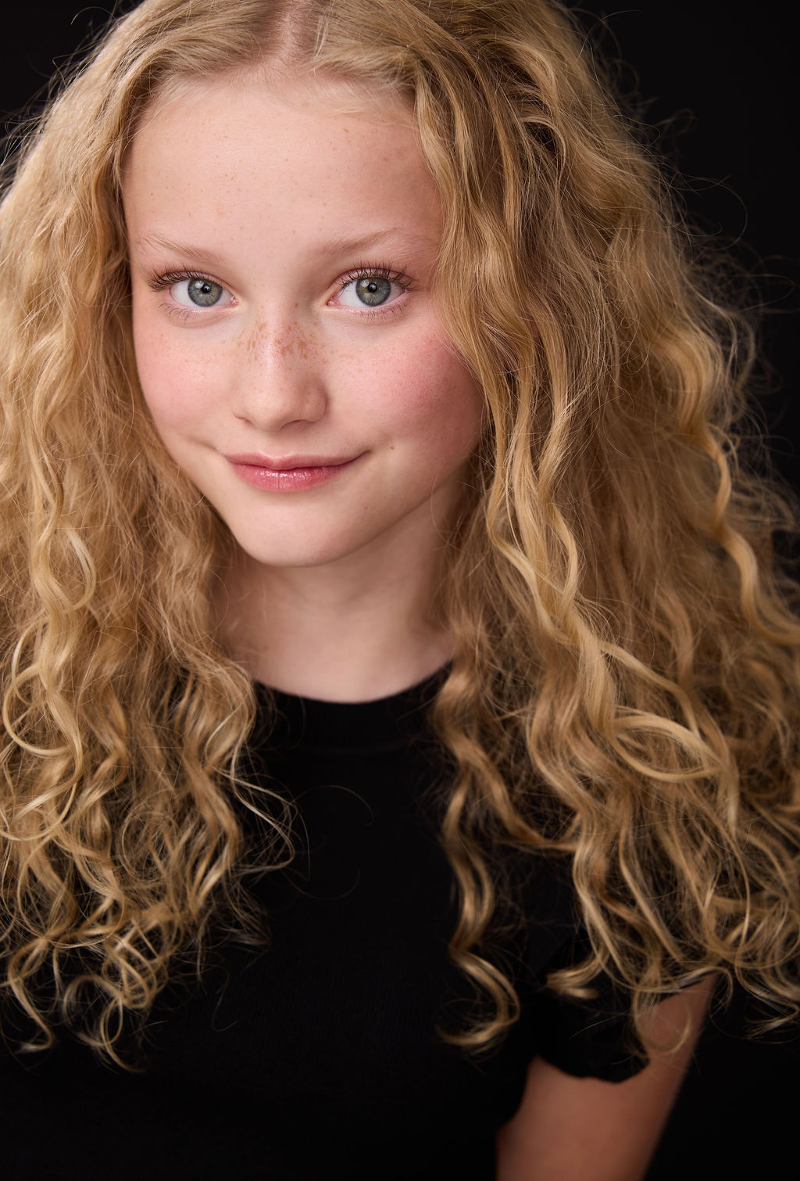 | SAMMIE  WILLIAMSON  A C T O R  HEIGHT: 5’0” WEIGHT: 80 LBS HAIR: BLONDE EYES: BLUE  _____________________________________________________  T R A I N I N G
  Advanced Acting Technique | Theresa Pittius | The Prep
  Acting Technique | Annie Abramczyk | The Prep
  Voiceover Technique | Taylor Kaplan | The Prep
  Crafting Comedy | Brandon Salerno | The Prep
  Performance Technique | Wendy Faraone | Talent House Academy
  Terminology / Scene Work | Krisha Bullock | Talent House Academy
  Acting Technique | Ashley Faulkner | Verve / Youth PTP
  Acting Technique | Cara Alvey | Actors Youth Theatre

FILM & TV
Coming Storm (Short Film) | Lead | Dir. Theresa Pittius  Punch You Entertainment
The Experiment | Lead | Dir. Theresa Pittius  Punch You Entertainment
Come Home | Lead | Dir. Theresa Pittius  Punch You Entertainment
The Hole | Lead | Mindclover Productions
Backseat Babysitting (Short) | Lead | Dir. Theresa Pittius  186 Productions
AWARDS
Almost Famous Film Festival - Best Breakout Performance
Show Low Film Festival - Best Youth Actor
SPECIAL SKILLS
Piano, Swimming, Accents and Dialects Available Upon Request
Sammie Williamson
SammieWilliamson.official@gmail.com | 317.979.2444
LA Local, NY Local, ATL Local, CHI Local

